DEPARTMENT OF ARTIFICIAL INTELLIGENCE AND DATA SCIENCE

INNOVATION IN TEACHING REPORT

Implementation of Real-Time Clock (RTC) Using Verilog HDL on Spartan-3 FPGA (XC3S400-PQ208) for Digital Design Laboratory
By
Mr. Durairaji V
Assistant Professor
Department of Artificial Intelligence and Data Science
St. Joseph’s College of Engineering
Chennai - 600119

- Innovation Type
Hardware-Based Experiential Learning using FPGA Prototyping
The innovation involves demonstrating a complete Real-Time Clock (RTC) system implemented using Verilog HDL on a Xilinx Spartan-3 FPGA (XC3S400-PQ208) development board. Students learn digital design concepts through real-time hardware execution rather than simulation alone.
- Course Details
Particular | Details
Course Name | Digital Principles and Logic Design
Laboratory | Digital Design Laboratory
Topic | Real-Time Clock using FPGA
Platform | Xilinx Spartan-3 FPGA XC3S400-PQ208
Programming Language | Verilog HDL
Software Tool | Xilinx ISE Design Suite
Clock Frequency | 4 MHz
Display Device | 6 - Digit Seven Segment Display
- Objectives
The innovative teaching activity aims to:
- Demonstrate real-time digital system design.
- Introduce FPGA-based hardware implementation.
- Explain clock division and timing circuits.
- Illustrate counter design using Verilog HDL.
- Familiarize students with synthesis, simulation, and hardware verification.
- Bridge the gap between theoretical digital electronics and industrial FPGA applications.

- Need for Innovation
Traditional teaching methods explain counters, registers, and timing circuits theoretically. Students often find it difficult to visualize how these concepts operate in real-time.
The FPGA-based RTC model provides:
Hands-on learning experience.
- Real-time observation of clock operation.
- Understanding of hierarchical digital design.
- Exposure to industrial FPGA technology.
- Improved problem-solving and debugging skills.
- Description of the Innovative Model
The RTC system was designed using Verilog HDL and implemented on the Spartan-3 FPGA board.
The system:
- Accepts a 4 MHz clock input.
- Generates a 1-second pulse using a clock divider.
- Maintains:
  - Seconds Counter (00–59)
  - Minutes Counter (00–59)
  - Hours Counter (00–23)
- Displays time on a six-digit seven-segment display.
- Resets automatically after 23:59:59.
The implementation uses:
- Cascaded BCD Counters
- Clock Divider
- Seven Segment Decoder
- Display Multiplexing Technique
The Verilog code creates a 1-second enable pulse from the 4 MHz clock and updates the counters sequentially.
PROGRAM:
module finalclock_verilog(sgout,dis,load,reset,clock);
output [7:0]sgout;
output [5:0]dis;
input reset,clock,load;
reg [3:0]sec1_rg,sec2_rg,min1_rg,min2_rg,hr1_rg,hr2_rg;
reg [21:0] pulsegen ;
reg [2:0]cnk2;
reg [3:0]mout;
reg [7:0]sgout_rg;
reg [5:0]dis_sig;
wire [3:0]sec1,sec2,min1,min2,hr1,hr2;
wire tc1,tc2,tc3,tc4,tc5,tc6,enable;

//reg tc,tc1,tc2,tc3,tc4,tc5,tc6,enable;
//reg sec1_rg(3:0),sec2_rg(3:0),min1_rg(3:0),min2_rg(3:0),hr1_rg(3:0);
//reg hr2_rg(3:0),pulsegen(21:0),sel(2:0);
//reg mout(3:0),sgout(7:0),ck1(22:0),cnk2(2:0);

//*************************** Pulse Generator ******************
always@(posedge clock or posedge reset)
begin
if (reset)
pulsegen <= 22'b0;
else
begin
//if (pulsegen == 22'b1111010000100100000000)
if (pulsegen == 22'b111101)
pulsegen <= 22'b0;
else
pulsegen <= pulsegen + 1;
end
end
//Enable signal to generate 1-sec pulse for sec1 counter

//assign enable = (pulsegen == 22'b1111010000100100000000) ; //enable signal for sec1 counter

assign enable = (pulsegen == 22'b111101) ; //enable signal for sec1 counter
//************************ Second_cntr1 *************************
always@(posedge clock or posedge reset)
begin
if (reset )
sec1_rg <= 4'b0000;
else if (load) begin
sec1_rg <= 4'b0100;
end
else
begin
if (enable)
begin
if (sec1_rg == 4'b1001)
sec1_rg <= 4'b0000;
else
sec1_rg <= sec1_rg + 1;
end
end
end

assign sec1 = sec1_rg;

//------------------tc1 signal to start sec2 counter---------------------------

assign tc1 = (sec1_rg == 4'b1001) && (enable == 1);

//--************************* Second_cntr2 ***********************
always@(posedge clock or posedge reset)
begin
if (reset )
sec2_rg <= 4'b0000;

else if (load) begin
sec2_rg <= 4'b0100;
end
else
begin
if (tc1)
begin
if (sec2_rg == 4'b0101) begin
sec2_rg <= 4'b0000;
end
else begin
sec2_rg <= sec2_rg + 1;
end
end
end
end

assign sec2 = sec2_rg;

//-------------------------tc2 signal to start min1 counter-------------------
assign tc2 = (sec2_rg == 4'b0101) && (tc1 == 1);

//--************************ Minute_cntr1 *************************
always@(posedge clock or posedge reset)
begin
if (reset )
min1_rg <= 4'b0000;

else if (load) begin
min1_rg <= 4'b0100;
end
else
begin
if (tc2)
begin
if (min1_rg == 4'b1001) begin
min1_rg <= 4'b0000;
end
else begin
min1_rg <= min1_rg + 1;
end
end
end
end

assign min1 = min1_rg;

//------------------------tc3 signal to start min2 counter--------------------
assign tc3 = (min1_rg == 4'b1001) && (tc2 == 1);

//--************************ Hour_cntr1 *************************
always@(posedge clock or posedge reset)
begin
if (reset)
min2_rg <= 4'b0000;

else if (load) begin
min2_rg <= 4'b0100;
end
else
begin
if (tc3)
begin
if (min2_rg == 4'b0101) begin
min2_rg <= 4'b0000;
end
else
begin
min2_rg <= min2_rg + 1;
end

end
end
end

assign min2 = min2_rg;

//---------------------tc4 signal to start hr1 counter--------------------------
assign tc4 = (min2_rg == 4'b0101) && (tc3 == 1);

//--************************ Hour_cntr1 *************************
always@(posedge clock or posedge reset)
begin
if (reset)
hr1_rg <= 4'b0000;

else if (load) begin
hr1_rg <= 4'b0001;
end
else
begin
if (tc6)
begin
hr1_rg <= 4'b0000;
end
else
begin
if (tc4)
begin
if (hr1_rg == 4'b1001) begin
hr1_rg <= 4'b0000;
end
else
begin
hr1_rg <= hr1_rg + 1;
end

end
end
end
end

assign hr1 = hr1_rg;

//---------------------tc5 signal to start hr2 counter--------------------------
assign tc5 = (hr1_rg == 4'b1001) && (tc4 == 1);

//------------------------tc6 signal to reset at 23:59:59--------------------------
assign tc6 = (hr2_rg == 4'b0010) && (hr1_rg == 4'b0011) && (tc4 == 1);

//--************************ Hour_cntr2 *************************
always@(posedge clock or posedge reset)
begin
if (reset)
hr2_rg <= 4'b0000;
else if (load) begin
hr2_rg <= 4'b0000;
end
else
begin
if (tc6)
begin
hr2_rg <= 4'b0000;
end
else
begin
if (tc5)
begin
if (hr2_rg == 4'b0010) begin
hr2_rg <= 4'b0000;
end
else
begin
hr2_rg <= hr2_rg + 1;
end

end
end
end
end

assign hr2 = hr2_rg;

always@(posedge pulsegen[9] or posedge reset)
begin
if (reset)
cnk2 <= 3'b0;
else
begin
if (cnk2 == 3'b101)
cnk2 <= 3'b0 ;
else
cnk2 <= cnk2 + 1;
end
end
always@(cnk2)
case (cnk2)
3'b000 : mout <= sec1;
3'b001 : mout <= sec2;
3'b010 : mout <= min1;
3'b011 : mout <= min2;
3'b100 : mout <= hr1;
3'b101 : mout <= hr2;
endcase
always@(mout)
case (mout)
4'b0000 : sgout_rg <= 8'b11000000;
4'b0001 : sgout_rg <= 8'b11111001;
4'b0010 : sgout_rg <= 8'b10100100;
4'b0011 : sgout_rg <= 8'b10110000;
4'b0100 : sgout_rg <= 8'b10011001;
4'b0101 : sgout_rg <= 8'b10010010;
4'b0110 : sgout_rg <= 8'b10000010;
4'b0111 : sgout_rg <= 8'b11111000;
4'b1000 : sgout_rg <= 8'b10000000;
4'b1001 : sgout_rg <= 8'b10011000;
endcase
always@(cnk2)
case (cnk2)
3'b000 : dis_sig <= 6'b111110;
3'b001 : dis_sig <= 6'b111101;
3'b010 : dis_sig <= 6'b111011;
3'b011 : dis_sig <= 6'b110111;
3'b100 : dis_sig <= 6'b101111;
3'b101 : dis_sig <= 6'b011111;
endcase
assign sgout = ~ sgout_rg;
assign dis = ~ dis_sig;
endmodule
- Hardware Setup
- Spartan-3 FPGA Board (XC3S400-PQ208)
- 4 MHz Crystal Oscillator
- Six-Digit Seven Segment Display Board
- Ribbon Cable Interface
- Power Supply
- FPGA Pin Assignments
Important pin mappings from the UCF (User Constraints File) file:
net clock loc = p181;
net reset loc = p182;
net load loc = p33;
net sgout<7> loc =p199;
net sgout<6> loc =p198;
net sgout<5> loc =p197;
net sgout<4> loc =p196;
net sgout<3> loc =p194;
net sgout<2> loc =p191;
net sgout<1> loc=p190;
net sgout<0> loc=p189;
net dis<5> loc = p10;
net dis<4> loc = p11;
net dis<3> loc = p12;
net dis<2> loc = p13;
net dis<1> loc = p15;
net dis<0> loc = p16;
- Working Principle
Step 1: Clock Division
The FPGA receives a 4 MHz clock.
A pulse generator divides the clock and generates a 1-second enable signal.
Step 2: Seconds Counter
- Counts from 00 to 59.
- Generates carry signal tc1.
Step 3: Minutes Counter
- Increments whenever seconds reach 59.
- Counts from 00 to 59.
Step 4: Hours Counter
- Counts from 00 to 23.
- Resets automatically after 23:59:59.
Step 5: Display Multiplexing
The six seven-segment displays are activated one after another at high speed to create continuous visualization.
- RTL (Register-Transfer Level) Schematic
The RTL design contains:
- Clock Divider Module
- Second Counter Module
- Minute Counter Module
- Hour Counter Module
- Seven Segment Decoder
- Display Multiplexer
The synthesized RTL schematic clearly shows the hierarchical implementation of the RTC design.
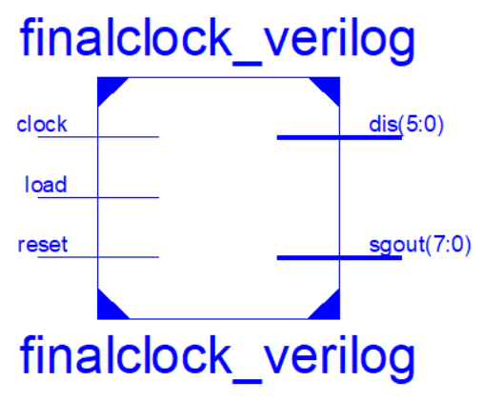
- Simulation Results
Observed outputs:
Time Display
01:47:03
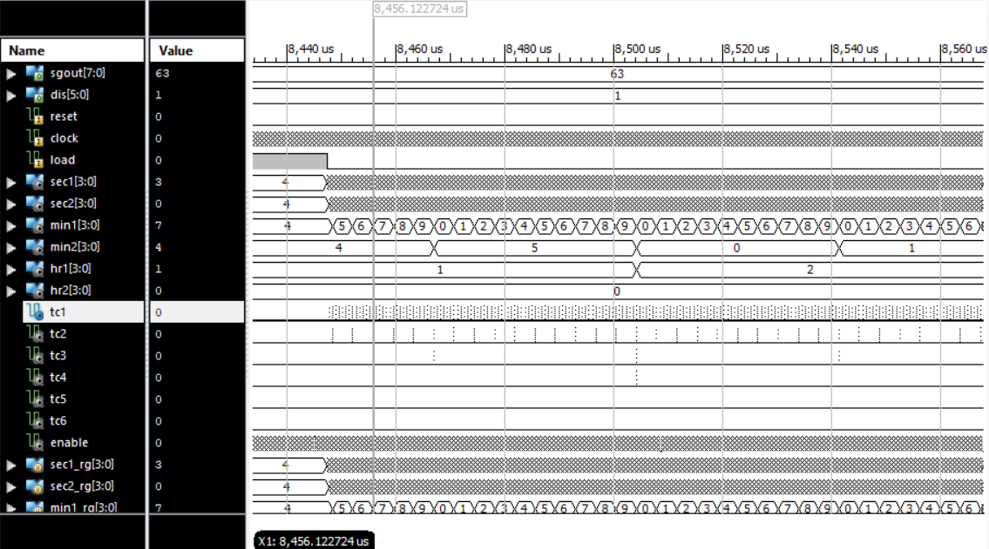

- Hardware Implementation
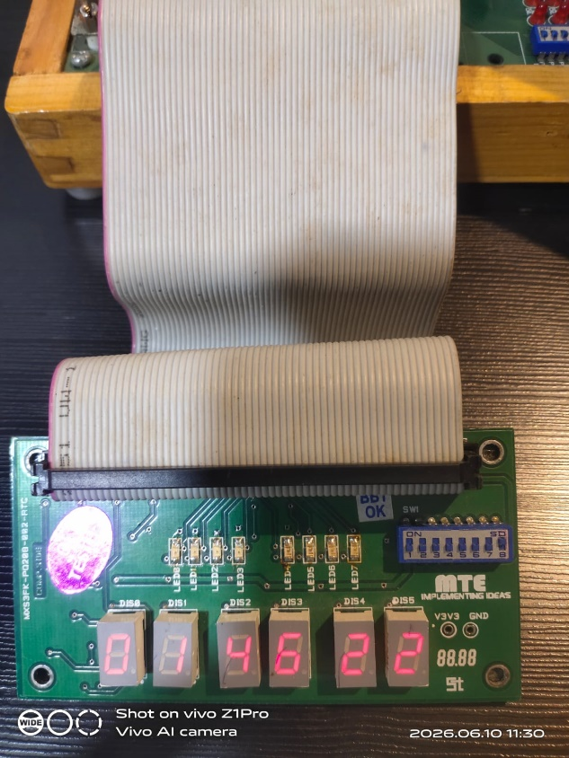 | 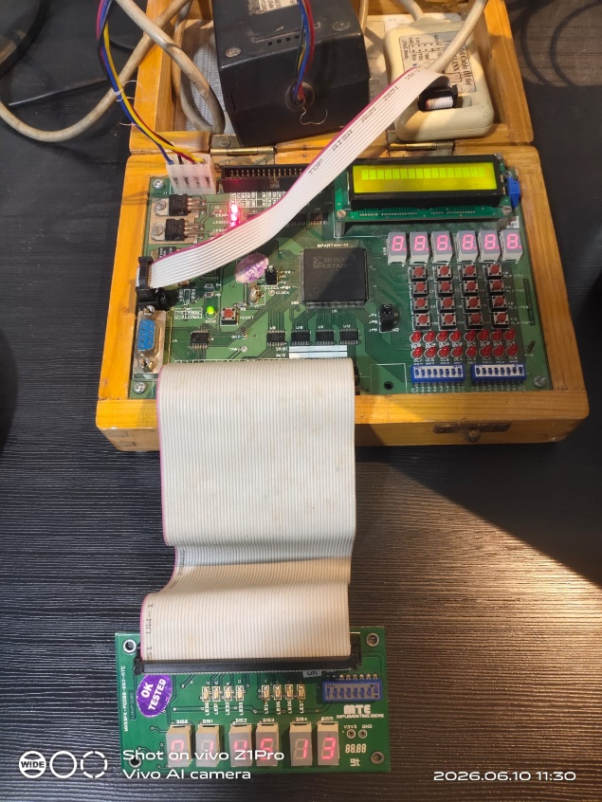
- Learning Outcomes
After performing this activity, students are able to:
- Design synchronous sequential circuits.
- Implement clock dividers.
- Develop Verilog HDL modules.
- Perform FPGA synthesis and implementation.
- Analyze RTL schematics.
- Verify functionality using simulation tools.
- Interface FPGA with seven-segment displays.
- Develop real-time embedded digital systems.
- Outcome-Based Education (OBE) Mapping
POs | Contribution
PO1 | Engineering Knowledge
PO2 | Problem Analysis
PO3 | Design of Solutions
PO4 | Investigation
PO5 | Modern Tool Usage
PO12 | Lifelong Learning
- Conclusion
The Real-Time Clock (RTC) implementation using Verilog HDL on Spartan-3 FPGA XC3S400-PQ208 is an effective innovative teaching model that transforms theoretical concepts of counters, timing circuits, and sequential logic into a practical real-time hardware application. The activity enhances student engagement, improves FPGA design skills, and provides industrial-level exposure to digital system development.
Innovation Outcome: Students achieved a better understanding of digital design concepts through real-time FPGA implementation, simulation verification, RTL analysis, and hardware testing.

